NAME: MARY ACHIENG OKOTH
REG NO: BIT/2024/74164
SCHOOL: COMPUTING AND INFORMATICS
PROGRAMME: MOBILE APPLICATION DEVELOPMENT
ACADEMIC YEAR: MAY/AUGUST
SEMESTER: YEAR 3 SEM 2
LECTURE: NYORO MICHAEL
PHONE:0707512632
SYSTEM DESIGN
Figure 1:Figma Wireframes and Prototypes
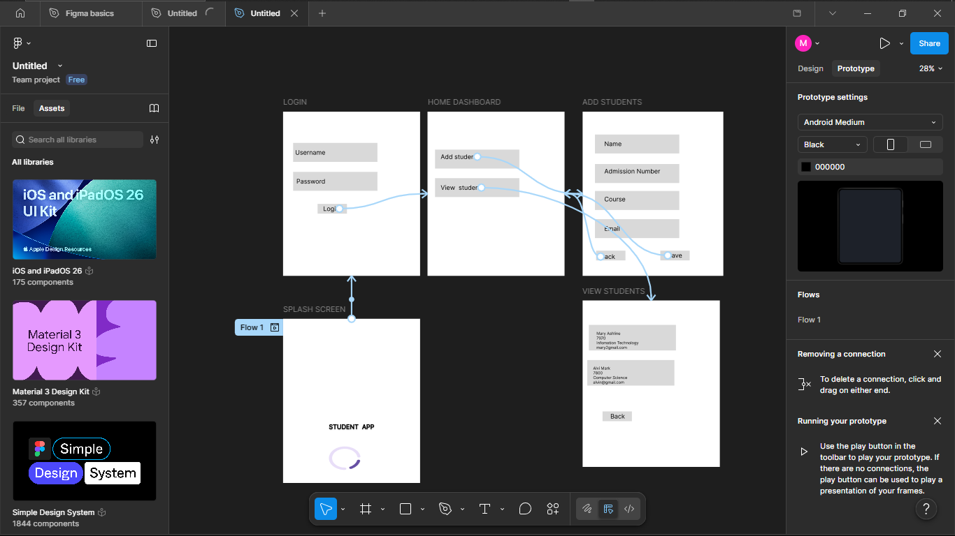

SYSTEM IMPLEMENTATION(Emulator)
Figure 2:Login Screen
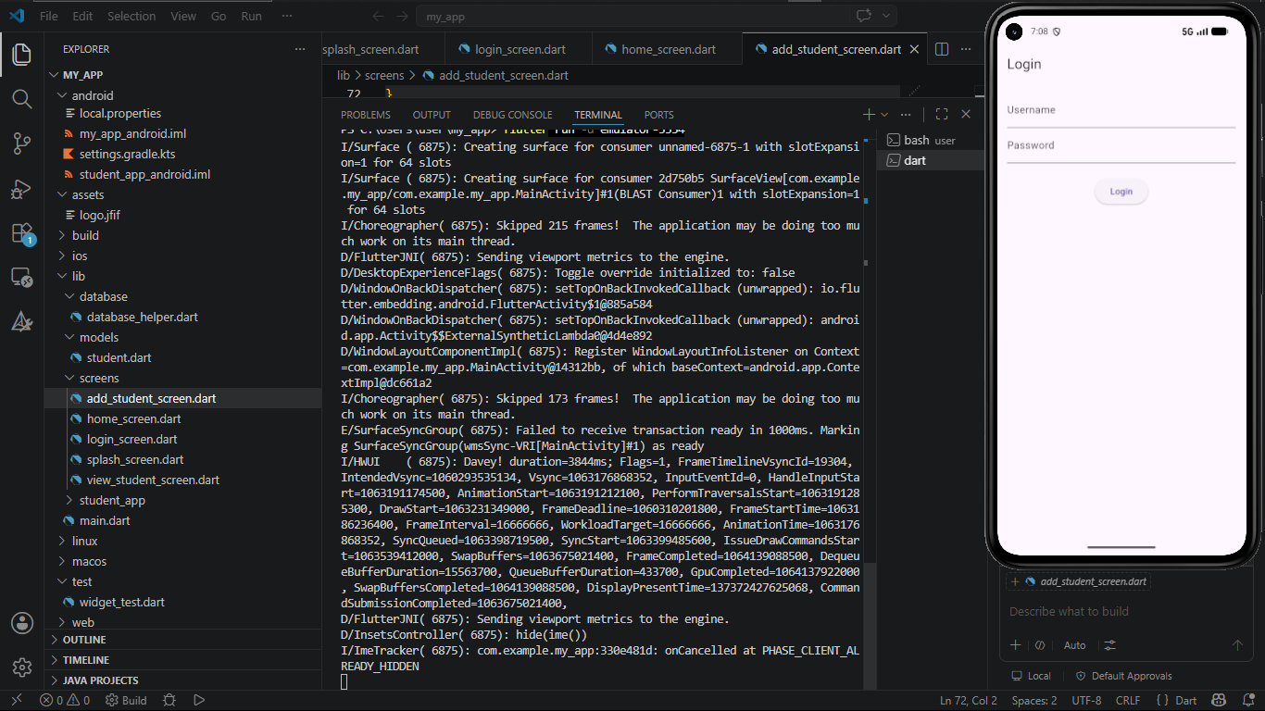

Figure 3:Home Dashboard Screen
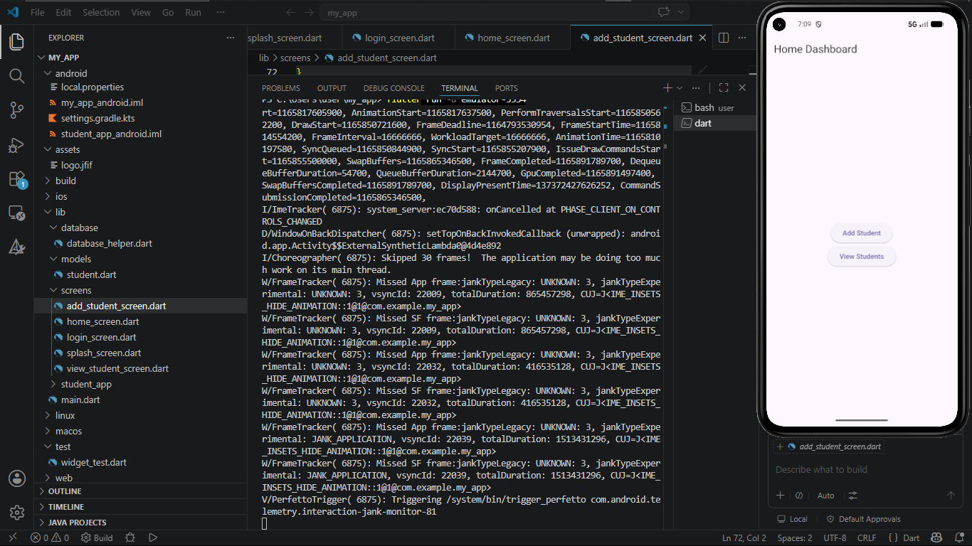
Figure 4:Add Student Screen
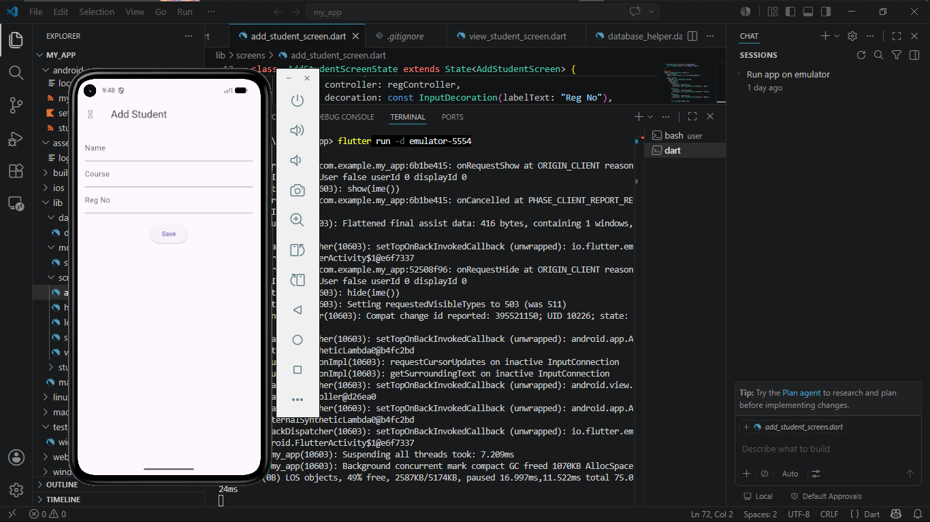
Figure 5:View Student Screen
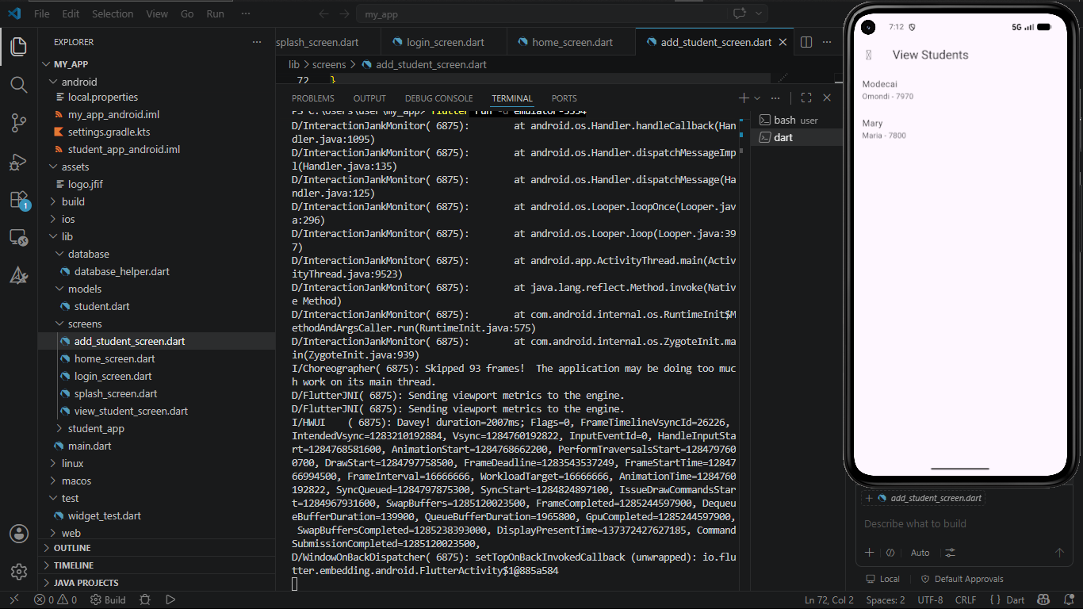

TECHNOLOGIES USED
- Flutter – UI development
- Dart – Programming language
- SQLite – Local database storage
- Android Studio – SDK & emulator setup
- VS Code – Code editor
- Android Emulator – Testing environment
- Figma – UI design and wireframing
- GitHub – Version control and hosting
PERSONAL REFLECTION
This project improved my skills in Flutter development, UI design, and database integration. I gained practical experience in building a functional mobile application and solving real development challenges during implementation and testing.

BIT/2024/74164: https://github.com/Achiengo-M/student_app
BIT4107 MOBILE DEVELOPMENT APPLICATION

